Euler's Formula

Definition
# Source: AI Source: Provided by: [Data Path: Persons Table -> ID Column: 1, Name_En Column: Motasem Essam] -> From: [ChatGPT] on [7/25/2026]
Euler’s formula for polyhedra is a mathematical relationship between the number of vertices, edges, and faces of a convex polyhedron.
It states that the number of vertices minus the number of edges plus the number of faces equals two.
$$\boxed{V-E+F=2}$$
Where:
- $V$ = number of vertices (corners)
- $E$ = number of edges (line segments joining vertices)
- $F$ = number of faces (flat polygonal surfaces)
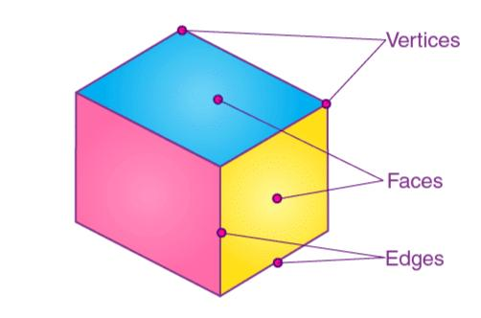
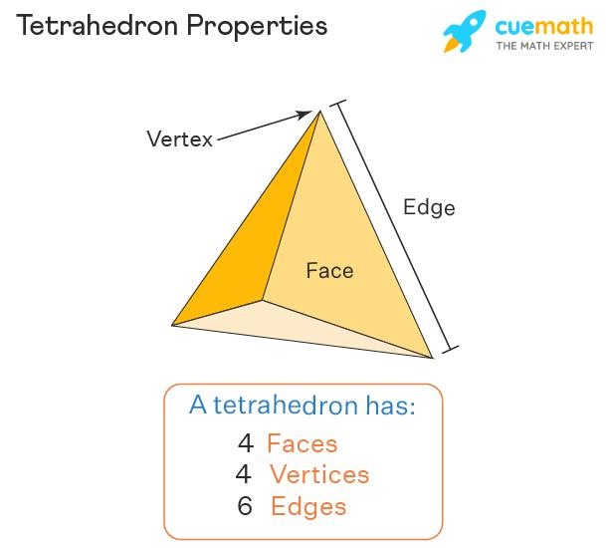
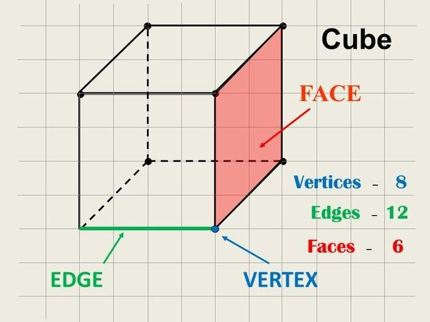

Simple definition
# Source: AI Source: Provided by: [Data Path: Persons Table -> ID Column: 1, Name_En Column: Motasem Essam] -> From: [ChatGPT] on [7/25/2026]
Euler’s formula tells us that, for a convex polyhedron, the numbers of corners, edges, and faces are related in a fixed way.
For example, a cube has:
- 8 vertices
- 12 edges
- 6 faces
Substituting these values:
$$V-E+F=8-12+6=2$$
Therefore, the cube satisfies Euler’s formula.

Classification
# Source: AI Source: Provided by: [Data Path: Persons Table -> ID Column: 1, Name_En Column: Motasem Essam] -> From: [ChatGPT] on [7/25/2026]
Euler’s formula in geometry is commonly discussed in these forms:
A. Euler’s polyhedron formula
$$V-E+F=2$$
Applies to convex polyhedra and more generally to polyhedral surfaces topologically equivalent to a sphere.
B. Rearranged forms
$$V=E-F+2$$
$$E=V+F-2$$
$$F=E-V+2$$
These forms help calculate a missing quantity when the other two are known.
C. Generalized Euler characteristic
$$V-E+F=χ$$
Here, $χ$ is the Euler characteristic. For a connected, closed, orientable surface of genus $g$, $χ=2-2g$.

Euler’s formula for common polyhedral
# Source: AI Source: Provided by: [Data Path: Persons Table -> ID Column: 1, Name_En Column: Motasem Essam] -> From: [ChatGPT] on [7/25/2026]
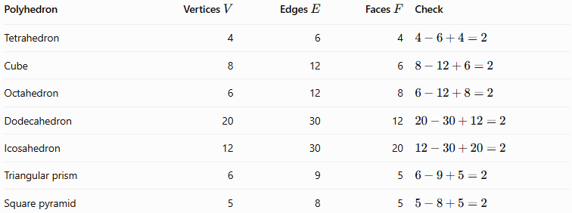
Polyhedron | Vertices $V$ | Edges $E$ | Faces $F$ | Check
Tetrahedron | 4 | 6 | 4 | $$4-6+4=2$$
Cube | 8 | 12 | 6 | $$8-12+6=2$$
Octahedron | 6 | 12 | 8 | $$6-12+8=2$$
Dodecahedron | 20 | 30 | 12 | $$20-30+12=2$$
Icosahedron | 12 | 30 | 20 | $$12-30+20=2$$
Triangular prism | 6 | 9 | 5 | $$6-9+5=2$$
Square pyramid | 5 | 8 | 5 | $$5-8+5=2$$
All the listed solids satisfy Euler’s formula.

Worked examples
# Source: AI Source: Provided by: [Data Path: Persons Table -> ID Column: 1, Name_En Column: Motasem Essam] -> From: [ChatGPT] on [7/25/2026]
Example 1: Find the number of faces
A convex polyhedron has 10 vertices and 15 edges. How many faces does it have?
Start with:
$$V-E+F=2$$
Substitute $V=10$ and $E=15$:
$$10-15+F=2$$
$$F-5=2$$
$$\boxed{F=7}$$
The polyhedron has 7 faces.
Example 2: Find the number of edges
A convex polyhedron has 12 vertices and 8 faces. Find its number of edges.
Rearrange Euler’s formula:
$$E=V+F-2$$
Substitute the known values:
$$E=12+8-2$$
$$\boxed{E=18}$$
The polyhedron has 18 edges.
Example 3: Check whether a proposed polyhedron satisfies Euler’s formula
A solid is described as having 6 vertices, 10 edges, and 6 faces.
Calculate:
$$V-E+F=6-10+6=2$$
The counts satisfy Euler’s formula. However, this check alone does not prove that a geometrically valid polyhedron with those counts exists; it is a necessary consistency check for a convex polyhedron.

How to use Euler’s formula
# Source: AI Source: Provided by: [Data Path: Persons Table -> ID Column: 1, Name_En Column: Motasem Essam] -> From: [ChatGPT] on [7/25/2026]
Step 1 — Identify the known values
Count the vertices, edges, and faces, or use the quantities provided in the question.
Step 2 — Substitute into the formula
Use $V-E+F=2$.
Step 3 — Solve or verify
Rearrange the equation to find the missing value, or check whether the counts satisfy the relationship.

Important limitations
# Source: AI Source: Provided by: [Data Path: Persons Table -> ID Column: 1, Name_En Column: Motasem Essam] -> From: [ChatGPT] on [7/25/2026]
- The formula $V-E+F=2$ applies to convex polyhedra.
- It also holds for connected, closed polyhedral surfaces that are topologically equivalent to a sphere, including certain non-convex polyhedra.
- It does not apply unchanged to every surface. A polyhedral surface with a handle, such as a torus, has Euler characteristic $0$, so $V-E+F=0$ for a suitable cell decomposition.
- A sphere, cylinder, or cone is not a polyhedron because its boundary is not made entirely of polygonal faces. The formula should not be applied by counting their curved surfaces as ordinary polygonal faces and their circular boundaries as polyhedral edges.

Key points
# Source: AI Source: Provided by: [Data Path: Persons Table -> ID Column: 1, Name_En Column: Motasem Essam] -> From: [ChatGPT] on [7/25/2026]
- Euler’s polyhedron formula is $V-E+F=2$.
- Vertices are corners, edges are line segments, and faces are polygonal surfaces.
- The formula can find a missing count or verify whether given counts are consistent.
- Satisfying the formula alone does not guarantee that a proposed solid exists.
- The generalized form uses the Euler characteristic, $χ$, to account for different surface topologies.

Conclusion
# Source: AI Source: Provided by: [Data Path: Persons Table -> ID Column: 1, Name_En Column: Motasem Essam] -> From: [ChatGPT] on [7/25/2026]
Euler’s formula is a fundamental relationship in solid geometry. It connects the vertices, edges, and faces of a polyhedron and provides a simple method for checking and calculating these quantities. It is especially useful when studying prisms, pyramids, and the five Platonic solids.

